**Practical 2**

**Q1**

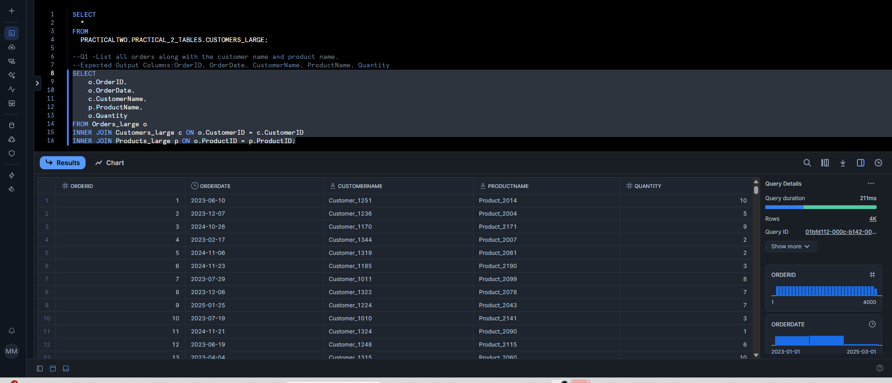

**Q2**

**Q3**

**Q4**

**Q5**

**Q6**

**Q7**

**Q8**

